**4435 – Project 2 – Simple Navigation App**

In This Project, You’ll Create A Simple Navigation App Using Google Maps. Your Application Must Include 2 Activities (1 – MainActiviy, 2 – Navigation Activiy)

When You Run The Application, MainActivity Will Be Executed. In This Activity, You’ll Have 2 Inputs and 1 Button.

1st Input : Enter Starting Address

2nd Input : Enter Destination Address

[Button] Start Navigation.

When User Enters Staring & Destination Addresses And Clicks Navigation Button, App Will Run Navigation Activity. (In This Activity You’ll Be Using Google Direction API)

In This Activity You’ll Have 2 Fragments (In A ViewPager With Tab Strip)

1st Fragment Will Show Google Map Screen

2nd Fragment Will Show Direction Hints In ListView.

1st Fragment : (Full Screen Google Map View)

According To You Starting And Destination Points, Map Will Have 2 Different Markers,

You’ll Draw The Route Between Those Markers, And You’ll Show User Current Location Also.

2nd Fragment : (Full Screen ListView Which Contains Entries From Google Direction API)

In This Fragment You’ll Have A ListView Which Is Going To Be Filled With The Data You’ve Received From Google Directions API (Also To Set Markers And Draw Route Between Those Markers, You’ll Use The Data From Google Directions API)

About Directions API :

https://developers.google.com/maps/documentation/directions/overview

For This Project You’ve To Create A Billing Account.

PROJECT DEADLINE

17.01.2021 23:30

**Information About Project Delivery**

As Stated In Course Syllabus, You Will Have 2 Individual Projects (Each Of Them Will Be 15% Of Your Course Grade). This Document Includes A Brief Explanation About How To Create & Compress Those Projects.

For Each Project, Project Name Must Be Like Following :

**PRJ_(1|2|3)_STUDENT_ID** For Example **PRJ_1_123456**

Package Name Of Your Project Must Be Like Following :

**prj_(1|2|3).stu_STUDENT_ID** For Example **prj1.stu_123456**

Projects Will Use Java Language (Not Kotlin) and Minimum SDK Will Be API 23 (Android 6.0)

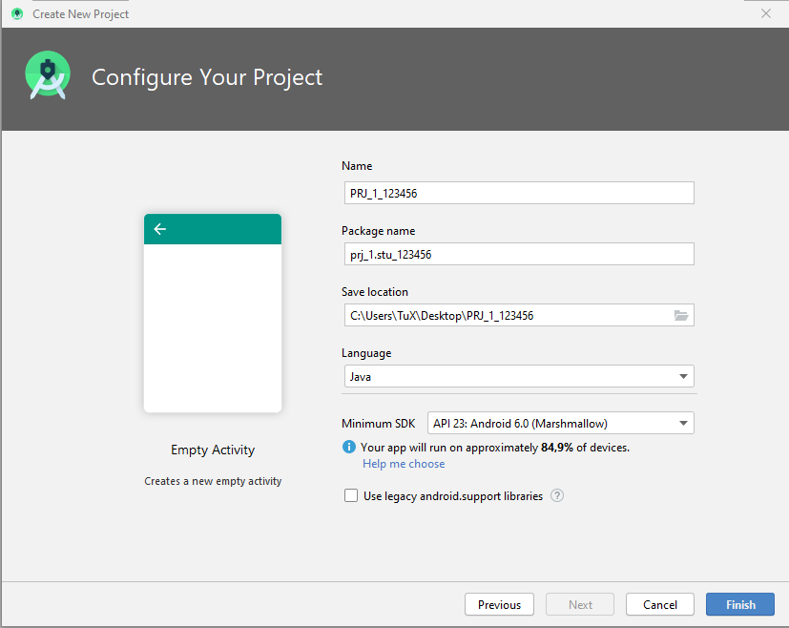

While Sending Your Project, You Must Send A Zip File (With: PRJ_1_STUDENT_ID.zip) Which Contains Only 2 Main Entries :

**PRJ_(1|2|3)_STUDENT_ID** -> Android Project Folder

**PRJ_(1|2|3)_STUDENT_ID.apk** -> Runnable, Android Application Package

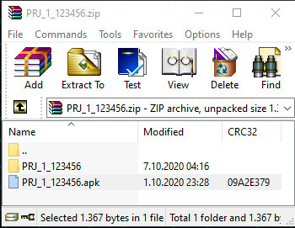

It’s Your Responsibility To Create, Pack And Upload Your Projects As Requested Format. If You Don’t, The Files You’ve Sent Will Be Neglected, And You’ll Get 0 For That Project.

If You Miss Deadline For Uploading A Project, You’ll Also Get 0 For That Project. (If You’re Having An Inevitable Excuse And Tell Me Before Deadline, I Might Give You Extra Time)

Your Will Deliver Your Project Via ItsLearning Platform.